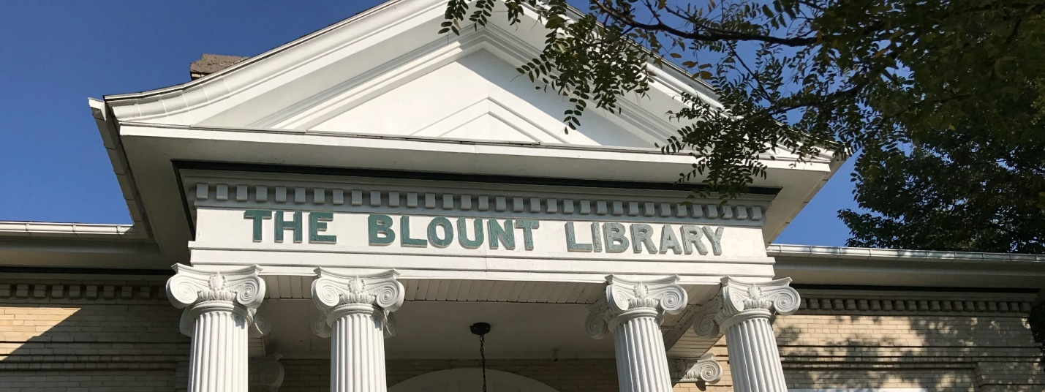

Blount Library
Franklinville, NY
Strategic Plan
2022-2026

Submitted by:
Jessica Frank, Library Director
director@franklinvillelibrary.org
(716) 676-5715

History

In 1839, the Franklinville Library Society was established with the sum of $100.00. In 1898, a Magazine and Library Club was organized by Mrs. Isadore McVey to obtain books and magazines and was set up in Morgan Hall on Park Square, and a bookmobile serviced Cadiz and Fitch. Through the efforts of the NYS Senator George Spring, President of the Library Board, Col. Henry Blount was contacted for his support. He eventually donated $5000.00 to help with building the original facility on the present site. An application was made to the Carnegie Corporation, and they agreed to give the sum of $2200.00 if the town would maintain the Library yearly.
The Library was supported through the Town and Village of Franklinville and the Franklinville Central School, together with donations from various organizations and patrons, until 2007 when the Library became a separate line of school tax assessments.
Kathryn Hawley, who was the Librarian from 1927 to 1974, left a large gift approximately $225,000.00, which was the basis of a building fund, and together with the donation of a lot from the Town of Franklinville and a mortgage, we built a 2600 square foot addition on the back of the original building, which is operating with more business hours and greater patron visits.
In 2009, an addition was made to the original building which increased the size of the library. The square footage is now 4081.

Dashboard

Vision

The Blount Library will foster the spirit of exploration, lifelong learning, the joy of reading and the pursuit of information and knowledge for all ages and cultures.

Mission Statement

The Blount Library, Inc., our mission is to provide a source to anyone seeking to enrich his or her minds and lives through knowledge, because we believe education creates possibility.

We value:
a. The involvement, participation and opinions of our patrons
b. Intellectual development
c. Literacy awareness for personal growth and pleasure
d. Appreciation of the visual and performing arts
e. Community betterment
f. A desire for excellence
g. Cooperation

Values

Goals and Objectives

